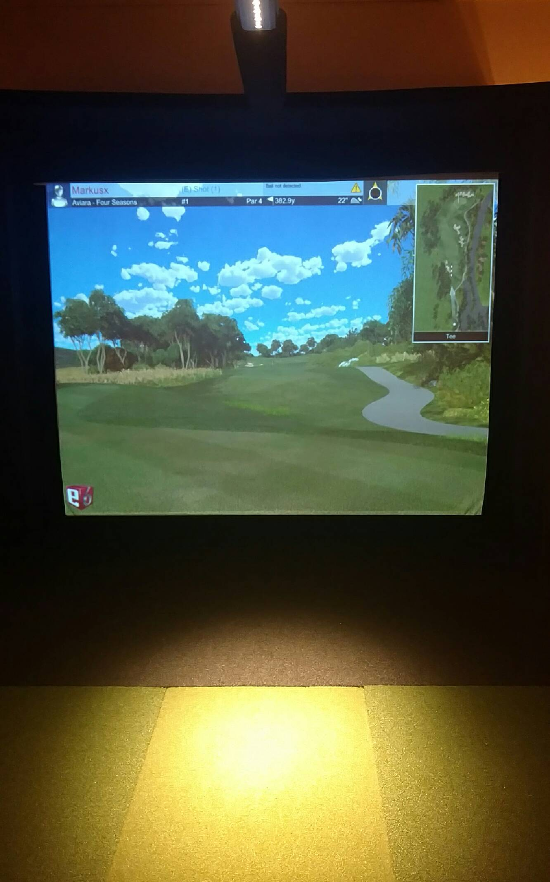

I would like to recommend and give everyone a chance to learn and craft your skills with a Highlander Alumni, Markus Mielke. He is in the area and has opened up a practice facility with a state of the art simulator.
You can play a round of golf/ go to the range and even play some games that interest you to improve your skill sets.
Markus is certified and also has the ability to help coach you through the mental side of the game as well. We are proud of Markus and he is offering any highlander a chance to meet him and begin improving your game in many areas. Some have taken the advantage and already do see Markus.
We hope you will give him a call and get ready for the season and summer ahead and beyond. He is open for just players that want to hit and/or those that want instruction, your call!!

If you’re a player for Adams ,call for an appointment and a Highlander special price of $65/hr.
-Coach Picot

Indoor Golf Instruction -365 Days a Year
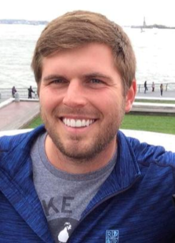
1880 Star Batt Drive, Rochester Hills, MI Contact Markus Mielke - (586) 206-9419

http://www.underpargolfinstruction.com/

